**ASSIGNMENT-2**

(B.Hemanth -192111338)

**PROGRAM:1-**There are four very old cave paintings. Find the oldest paintings using else if ladder in c++. 4200 years old,8500 years old,1000 years old,1300 years old

#include <iostream>

using namespace std;

int main()

{

int years[] = {4200, 8500, 1000, 1300};

int oldestYear = years[0];

for (int i = 1; i < 4; i++)

{

if (years[i] > oldestYear)

{

oldestYear = years[i];

}

}

cout << "The oldest painting is " << oldestYear << " years old." << std::endl;

return 0;

}

**OUTPUT:** 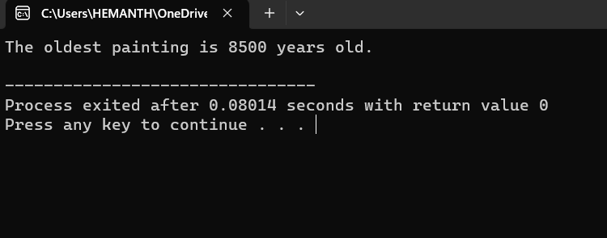

**PROGRAM 2:-**One bus can carry 48 children. How many children can three buses carry. Write a c++ program using parameterized constructor.

#include <iostream>

class Bus {

private:

int capacity;

public:

Bus(int capacity) {

this->capacity = capacity;

}

int calculateChildren(int numberOfBuses) {

return capacity * numberOfBuses;

}

};

int main() {

int busCapacity = 48;

int numberOfBuses = 3;

Bus bus(busCapacity);

int totalChildren = bus.calculateChildren(numberOfBuses);

std::cout << "Three buses, each carrying " << busCapacity << " children, can carry a total of " << totalChildren << " children." << std::endl;

return 0;

}

**OUTPUT:**

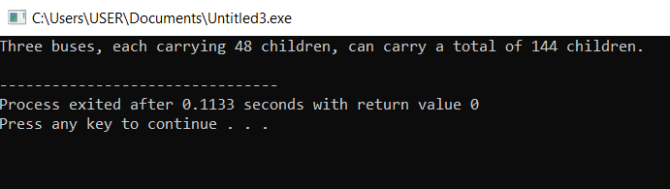

**PROGRAM 3:-**Kiran bought 1 kg plastic for $10, but sold plastic for $12. How much money does she earn on selling 1 kg plastic. Write a c++ program using default constructor.

#include <iostream>

class Plastic {

public:

Plastic() {

costPrice = 10.0;

sellingPrice = 12.0;

}

double calculateProfit() {

return sellingPrice - costPrice;

}

private:

double costPrice;

double sellingPrice;

};

int main() {

Plastic kiranPlastic;

double profit = kiranPlastic.calculateProfit();

std::cout << "Kiran made $" << profit << " on selling 1 kg of plastic." << std::endl;

return 0;

}

**OUTPUT:**

